Final Project

Computer Networking Course

**Dolev Abuhazira (205776321) , Shlomo Glick (312566649)**

**Part 1:**

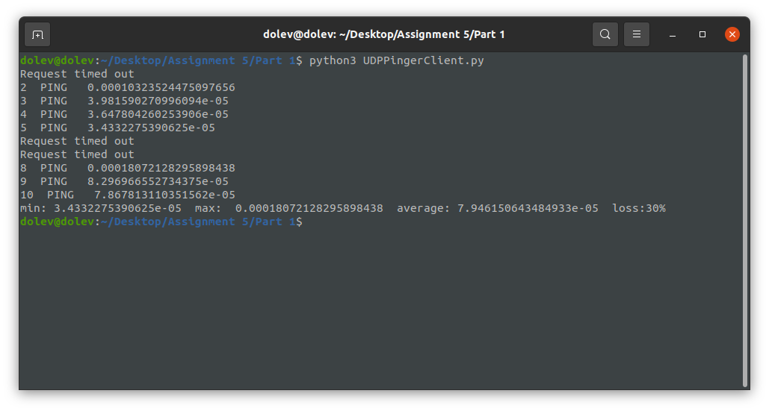

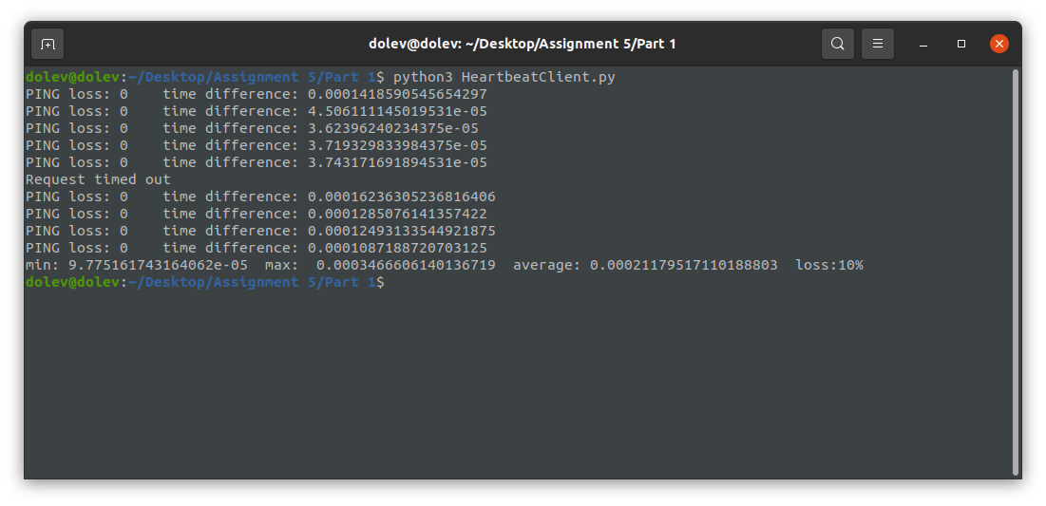

**Part 2:**

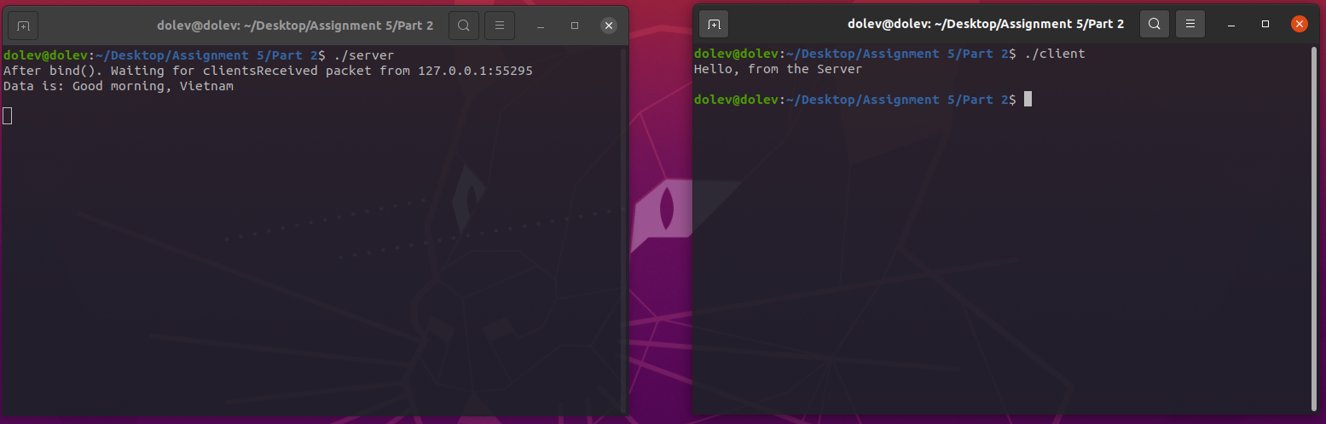Screen shot of two programs, client and server that used IPv4 :

Screen shot of using the netstat -na command before running the programs :

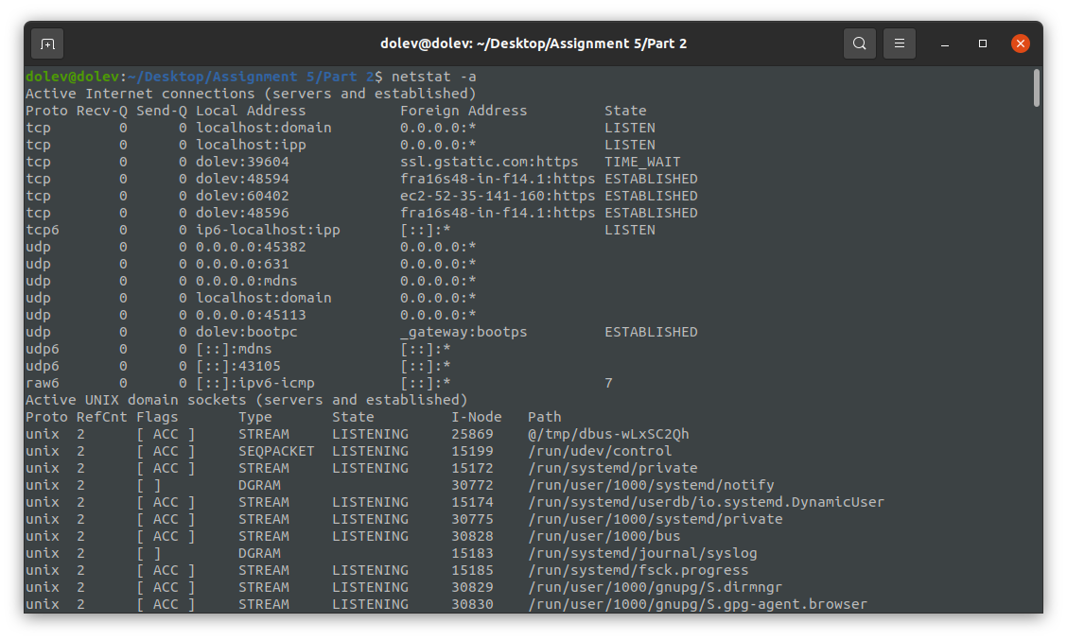

Screen shot of using the netstat -na command after running the programs :

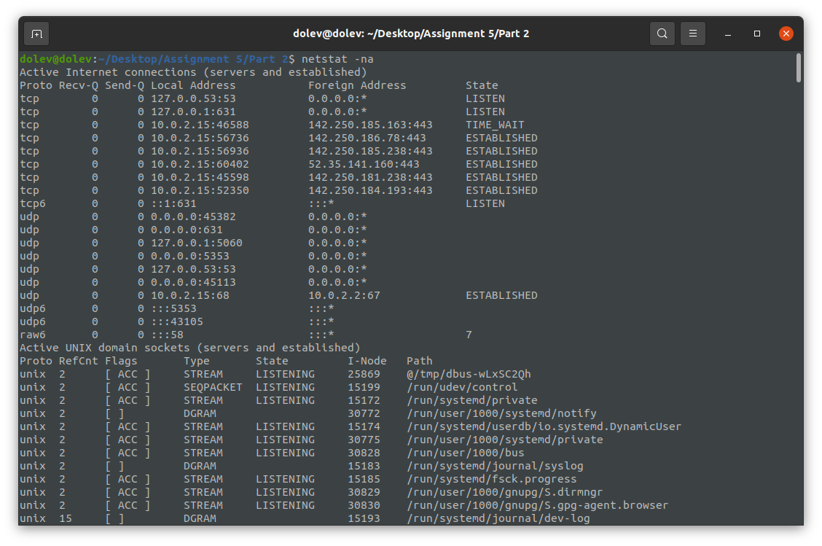

Screen shot of two programs, client and server that used IPv6 :